**Table of Content**

**CHAPTER 1: INTRODUCTION ................................................................................................ 4**

1. **INTRODUCTION ............................................................................................................ 4**
   1. ABOUT THE SYSTEM ........................................................................................................... 3
   2. PURPOSE ........................................................................................................................ 4
   3. SCOPE ............................................................................................................................ 4
   4. VISION ........................................................................................................................... 4
   5. System Necessity .........................................................................................................4
   6. PROPOSED SOLUTION ...................................................................................................... .4

**CHAPTER 2: SYSTEM ANALYSIS .......................................................................................... 5**

1. **SYSTEM ANALYSIS ....................................................................................................... 5**
   1. ACTOR GOAL LIST ............................................................................................................ 5
   2. USE CASE MODEL............................................................................................................ 6
   3. Break Down of Use Case (BRIEF) ................................................................................. 7
      1. *Manage User account..........................................................................................7*
      2. *Manage Committee Members.............................................................................7*
      3. *Manage Profile……………………...............................................................................8*
      4. *Apply for Jobs ......................................................................................................8*
   4. USE CASE DESCRIPTION (DETAILED)............................................................................... 9-11
      1. *Manage User account..........................................................................................9*
      2. *Manage Committee Members.............................................................................10*
      3. *Manage Profile……………………...............................................................................10*
      4. *Apply for Jobs ......................................................................................................11*
   5. SYSTEM SEQUENCE DIAGRAM ........................................................................................... 11
      1. *Manage User account..........................................................................................11*
      2. *Manage Committee Members.............................................................................12*
      3. *Manage Profile……………………...............................................................................12*
      4. *Apply for Jobs ......................................................................................................13*
   6. ACTIVITY DIAGRAM ........................................................................................................ 14

**CHAPTER 3: SYSTEM DESIGN .......................................................................................... 15-18**

1. **SYSTEM DESIGN ........................................................................................................... 15**
   1. SEQUENCE DIAGRAM ....................................................................................................15-17
   2. CLASS DIAGRAM .............................................................................................................. 18

**CHAPTER 4: IMPLEMENTATION ...........................................................................................19**

1. **IMPLEMENTATION .......................................................................................................19**
   1. TOOLS AND TECHNOLOGIES .................................................................................................19

**CHAPTER 5: Project Link ......................................................................................................19**

Git-Hub Repositories…….................................................................................................19

**Chapter 1: Introduction**

## 1. Introduction

### The project, named by EARS (Employee Application Review System) is a project which is targeted to enhance job application review system & automate those as best as possible. By using this system, Steering committee of the company will have the access to judge the best applicant by his profile (CV & other things).

### 1.1. About the system

This system can be used for Online Job Portal or any other company who wants their job circular system & applicant ranking system to be automated. The system will cover those features:

* Login to Account
* Manage Accounts (View, Approve, Delete, Reject)
* List all the Application
* Profile Management
* Search according to Faculty
* Add Faculty
* Rank Applications (By their skill level)

### 1.2. Purpose

This system will automate the applicant ranking process, besides it’ll also reduce hassle for both applicants & the faculty members of respected company who will use the system. As we know, there are lots of applications are dropped against one circular. It is stressful to check all those by reading those manually (offline/online), but within this system Applicant can give his preference by a format defined by the system through online. So it’ll be easier to lighten those manual works & this will be done automatically by the system.

### 1.3. Scope

Employee Application Review System will be developed to ensure those offline tasks that should be automated & make it digitalized.

* Applicant--someone who is opened an account to apply for jobs.
* Steering Committee—those people who are in the main panel of their job portal board.
* Job Offerings, Application Ranking system can be optimized by faculty members’ choice.
* Implement changes easy as one, two, and three.

### 1.4. Vision

### Vision of the system is to lighten manual workloads of application review system, Besides enhance the edge of access both from the applicant & Faculty members end. Applicants can easily apply for various jobs or different posts, can update their profile on the other hand companies task will be lesser to pick the right applicant who is right for the position.

### 1.5 System Necessity

From the long ago there is the system that applicant used to find papers, write much CVs, going to various office to just drop their application. The companies also needed to allot circulars through are or to give advertisement on papers. There were lots of pressure to choose the right one to make call. But EARS will solve the problem for both. Tasks will be automated & easier with almost no stress.

### 1.6 Proposed Solution

### ✓ Online Web Portal

* Online Data Storage
* Search facility according to criteria
* Application Review System

**Chapter 2: System Analysis**

## 2. System Analysis

### 2.1. Actor-Goal List:

|  |  |
| --- | --- |
| *Actor* | *Goal* |
| Steering Committee Members | Maintaining all information as Manage Account,  Manage Members,  Review Applications |
| Applicant | Application submission for Jobs,  Manage self-profile |

2.2. Use Case Model

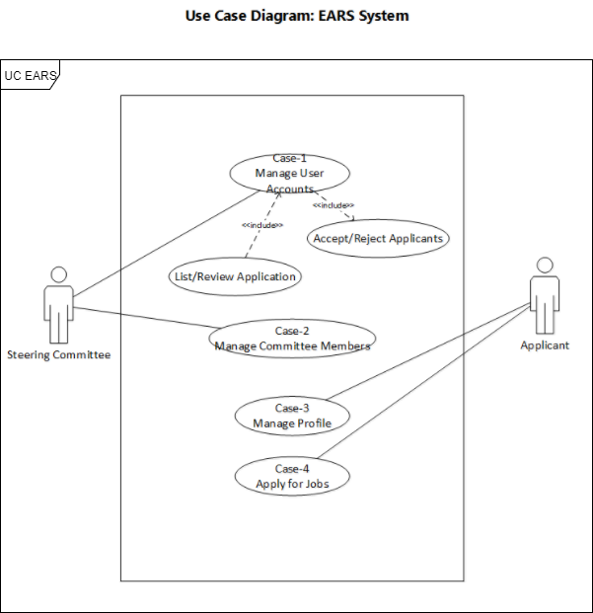

Fig: 2.1 Use Case Diagram

### 2.3. Break Down of Use Case

#### 2.3.1. Manage Account

Steering committee members have the right to do the following actions for the applicants.

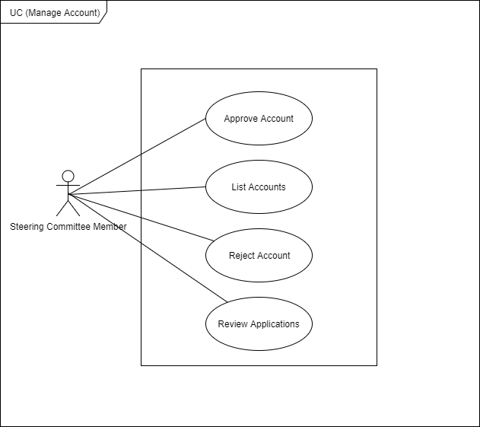

Fig: 2.2 use case diagram to Manage Accounts

#### 2.3.2. Manage Committee Members

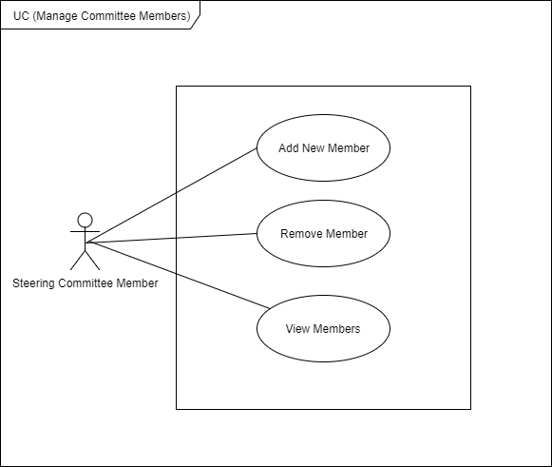

Fig: 2.3 use case diagram to Manage Committee Members

2.3.3. Manage Profile

Applicants must have their approved account to manage their profile.

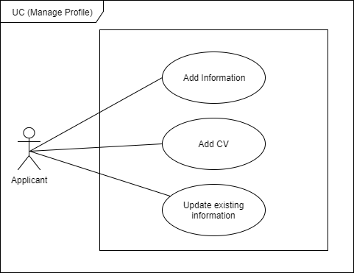

Fig: 2.3.3 use case diagram to manage profile

# 2.3.4. Apply for Jobs

Applicants who have an approved account can apply for jobs.

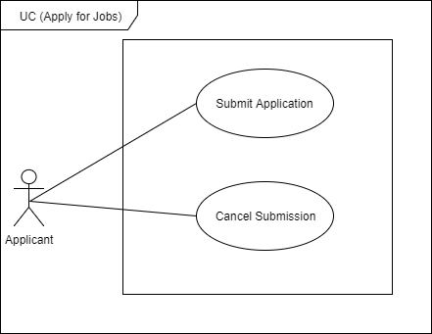

Fig: 2.3.4 use case diagram to Apply for jobs

### 2.4 Use Case Description (Detailed)

Here is the description of every single use case as the brief may not clear everyone to make

Description of Use Case-1: Manage User Accounts

Scope: New accounts can be added

Level: Admin Level

Primary Actor: Admin

Preconditions: Sign Up from users (Submit Name, E-mail, Age, Username, Passwords)

Post Conditions: Valid Information

Success scenario of Use Case-1: Manage User Accounts

1. All entries are enlisted
2. Check Information
3. Add Users
4. Remove Users

Failure scenario of Use Case-1: Manage User Accounts

* 1. Entries didn’t appear

2.1. False Information given

3.1. User addition option doesn’t work

4.1. Removing user option doesn’t work

Description of Use Case-2: Manage Committee Members

Scope: New accounts can be added

Level: Admin Level

Primary Actor: Admin (selected by STRC member panel)

Preconditions: Sign Up from users (Submit Name, E-mail, Age, Username, Passwords)

Post Conditions: Valid Information

Success scenario of Use Case-2: Manage Committee Members

* 1. All Members are shown
  2. Check Information
  3. Add Members
  4. Remove Members

Failure scenario of Use Case-2: Manage Committee Members

* 1. Users didn’t appear properly

2.1. False Information given

3.1. Member addition option doesn’t work

4.1. Removing member option doesn’t work

Description of Use Case-3: Manage Profile

Scope: Applicant/User can change, edit, update, add self-information

Level: User Level

Primary Actor: User

Preconditions: Must have an account

Post Conditions: Account should be verified, valid as well

Success scenario of Use Case-3: Manage Profile

1. User can update his account information including e-mail id, password, user name
2. User can update his CV

Failure scenario of Use Case-3: Manage Profile

* 1. User can’t change his password or other information

2.1. User can’t update his CV information

Description of Use Case-4: Apply for Job

Scope: User can apply against his preferable job offering

Level: User Level

Primary Actor: User

Preconditions: Must be logged in to the site (From valid account), View Job Posts

Post Conditions:

Success scenario of Use Case-4: Apply for Job

1. User can apply for any post in any job offerings
2. User can send extra documents with application

Failure scenario of Use Case-4: Apply for Job

* 1. User can’t apply to any job offerings
  2. User can’t apply every job offerings

2.1. User can’t attach extra documents

* 1. System Sequence Diagram

#### 2.5.1 Manage User Accounts

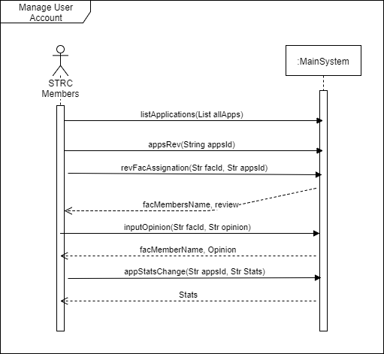

Fig: 2.5.1 system sequence diagram for Manage User Accounts

#### 2.5.2 Manage Committee Members

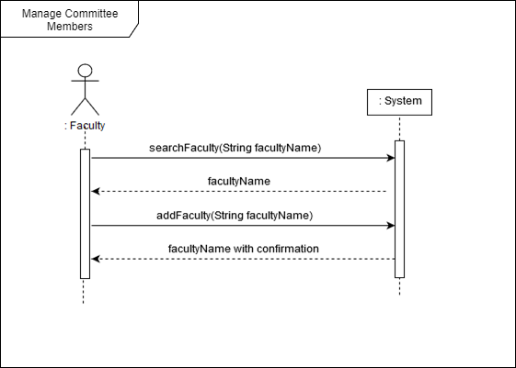

Fig: 2.5.2 system sequence diagram for manage committee members

#### 2.5.3 Manage Profile

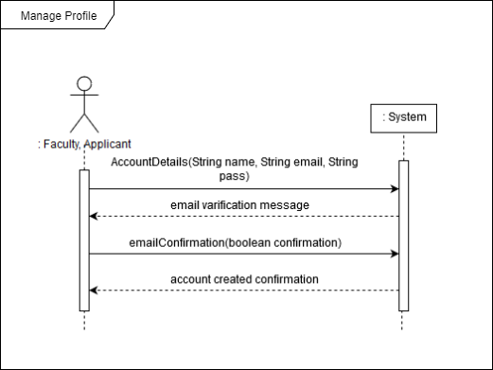

Fig: 2.5.3 system sequence diagram for Managing Profile

#### 2.5.4 Apply For Jobs

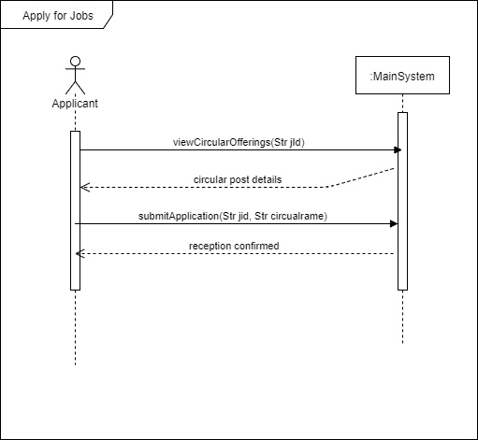

Fig: 2.5.4 system sequence diagram to Apply for jobs

### 2.6 Activity Diagram

Activity diagrams are graphical representations of workflows of stepwise activities and actions with support for choice, iteration and concurrency.

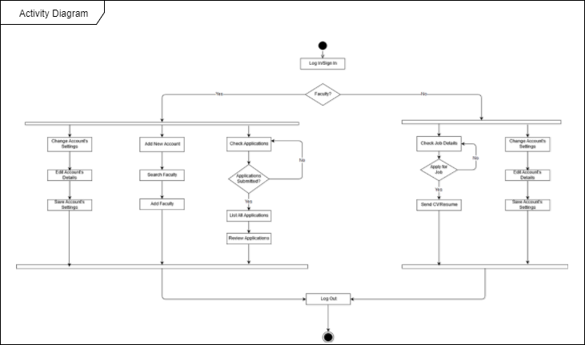

Fig: 2.7 Activity Diagram

**Chapter 3: System Design**

## 3 System Design

Systems design is the process of defining the architecture, components, modules, interfaces, and data for a system to satisfy specified requirements. Systems design could be seen as the application of systems theory to product/system development.

### 3.1 Sequence Diagram

The UML includes interaction diagrams to illustrate how objects interact via messages. They are used for dynamic object modeling.

#### Manage User Accounts

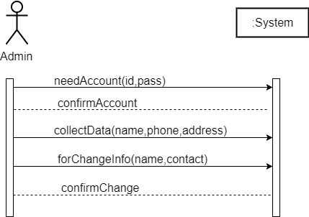

Fig: sequence diagram for Manage User Accounts

#### Manage Committee Members

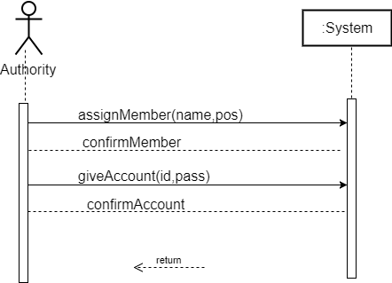

Fig: sequence diagram for manage committee members

#### Manage Profile

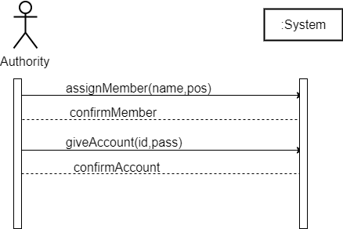

Fig: sequence diagram for Managing Profile

#### Apply For Jobs

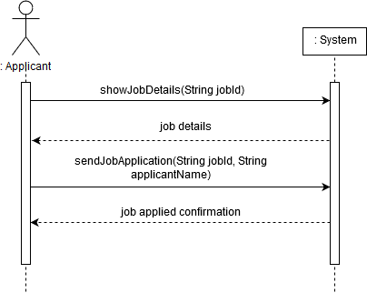

Fig: sequence diagram to Apply for jobs

### 3.2 Class Diagram

A class diagram in the Unified Modeling Language (UML) is a type of static structure diagram that describes the structure of a system by showing the system's classes, their attributes, operations (or methods), and the relationships among objects.

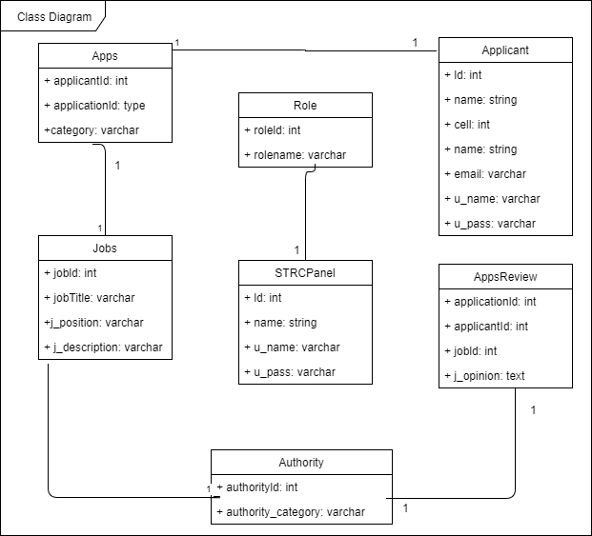

Fig: 3.2 Class Diagram

**Chapter 4: Implementation**

## 4 Implementation

### In an information technology (IT) context, software or hardware implementation encompasses all the post-sale processes involved in something operating properly in its environment, including analyzing requirements, installation, configuration, customization, running, testing, systems integrations, user training, delivery and making necessary changes. The word "deployment" is sometimes used to mean the same thing.

### Tools and technologies

For developing this system what tools and technologies will be used are given below:

* OS: Windows 10
* Database: MySql
* Front End: Html5, CSS3, Bootstrap
* Script: java script
* Back End: PHP
* Browsers: MS Edge, Chrome
* Diagram are drawn using draw.io (except use case diagram, only use case is drawn by MS Visio 16)

**Chapter 5: Project Link**

\*\****Git-Hub Repo:***

**https://github.com/mahbub1/Web-Projects**